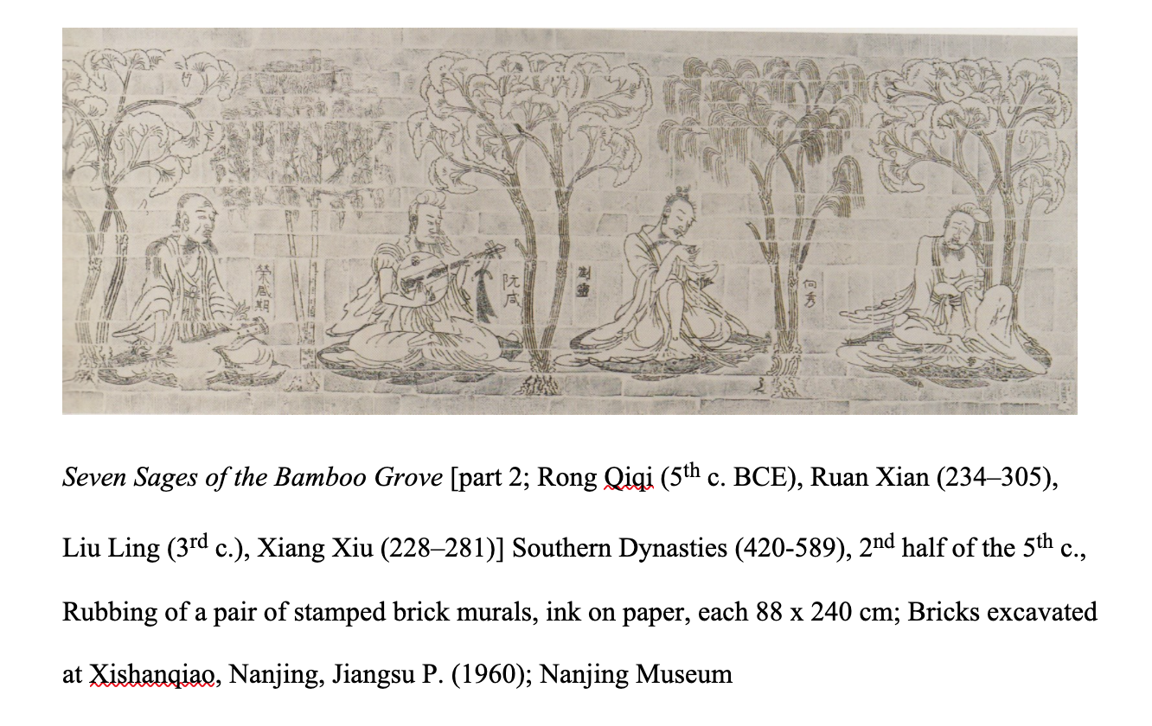
This stone rubbing presents the image of the Seven Sages in the bamboo grove: a famous group of Chinese intellectual elites in the 3rd century, who drank and talked and composed poetry together despite the political turmoil. Bamboo is a popular subject matter in Chinese art that symbolises gentlemen’s fine moral qualities: they were supposed to bow to circumstances without yielding.

The original brick mural was excavated from an elite tomb in the capital region of the Southern Dynasties. In this rubbing, the horizontal and vertical lines record the natural textures of brick murals; thus, the ink pigment is deposited over protrusions and the depressions remain unpigmented. This rubbing technique renders material on the paper, which has been used by many Chinese art historians to transfer the image or calligraphy from stone engravings. This rubbing is a part of the brick mural, which shows three Sages of the bamboo grove and a Chinese hermit and scholar Rong Qiqi, who is a contemporary of Confucius in the Spring and Autumn period. The space of each figure was well-framed by trees, such as gingko and willow; and the shade of different trees neatly arranges a symmetric composition. In terms of symbolism, different species of trees on this rubbing denote these men’s great personalities: aloofness and transcendence.

Poses, gestures and facial depictions indicate each figure’s personality and temperament, detaching from Confucian decorum to celebrate individual freedom. The drapes of four figures’ garments reflect the weight of fabric. Although the renderings of clothes are a little dishevelled, these details contribute to illustrate the Seven Sages’ uninhibited way of living. With the aid of inscriptions alongside each figure, we can clearly recognise each person from the left to right. For example, Xiang Xiu closed his eyes and leaned against the gingko, looks like being immersed in a meditation. As exemplified by Liu Ling’s writings, he is fond of drinking alcohol and despises the rituals of Confucianism. Hence, the portrayal of Liu Ling presents an image of a drinker using a wooden dipper to drink and plunge gladly into inebriation.

As the Tang dynasty poet Wangwei depicted in his poem Bamboo Grove Pavillion, the Ruan (a Chinese lute) is reference to these ancient sages, particularly with Ruan Xian, who is said to be the inventor of Ruan. It can be observed that Ruan Xian enjoys playing the Chinese lute on the ground; correspondingly, the much earlier legendary figure Rong Qiqi plays Guzheng (a Chinese plucked zither) in a sitting position. He looks like a preacher teaching his students to play an instrument; therefore, I assume the reason that depicting Rong alongside with the seven sages because the seven sages thought of Rong as their role model. Also, the embodiment of the Daoist essence of wuwei (effortless action) is underscored by depicting these scholars together. Further, the bamboo grove has become as an idealised place to escape from the political and social chaos in reality, like the Peach Blossom Spring.

